**Journey Through The Bible**

**Zacchaeus**

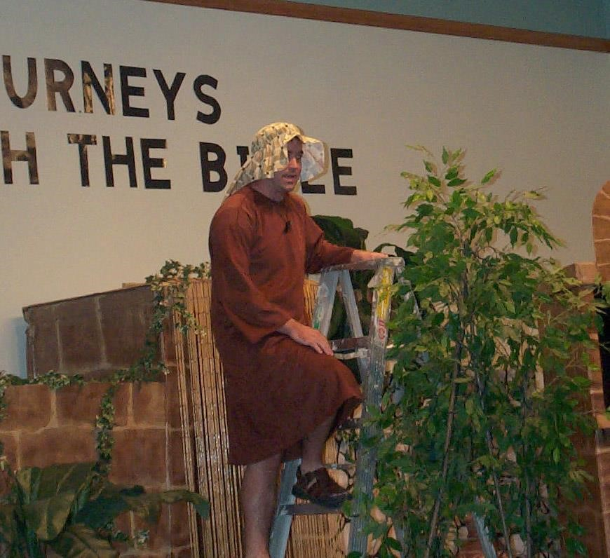

My name is Zacchaeus, and I live in a city called Jericho. I’m going to tell you boys and girls about the most exciting thing that ever happened to me.

One day I heard that Jesus was passing through our city, so I was trying my best to see who Jesus was. I am a short man, so I could not see above the crowd. I then climbed up into a sycamore tree, so I would have a good view of Jesus as He passed by me.

Was I ever surprised when Jesus stopped, looked up into the sycamore tree, and said to me, “Zacchaeus, hurry and come down, for I must stay at your house today.” He actually knew my name. I didn’t understand, but I hurried down and was thrilled to welcome Jesus to my home.

All of the people who saw this happen began to grumble because Jesus was going to the house of one they considered to be a sinner. I was disliked by the people of Jericho, because I was rich and a chief tax collector.

I said to Jesus, “Look, half of my possessions, Lord, I will give to the poor; and if I have defrauded anyone of anything, I will pay back four times as much.”

Jesus then said to me the most wonderful words that I have ever heard, “Today salvation has come to this house, because he too is a son of Abraham. For the Son of Man came to seek out and to save the lost.”

Jesus changed my life by making me a better person. I am thankful to God for Jesus who saves the lost. My journey comes from the book of Luke and now I would like to ask you some questions. (Prepare questions to ask about your character.)

**Scripture reading**: Luke 19:1-10

**Memory Verse:** Matthew 5:16

Let your light so shine before men, that they may see your good works and glorify your Father in heaven.